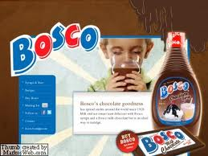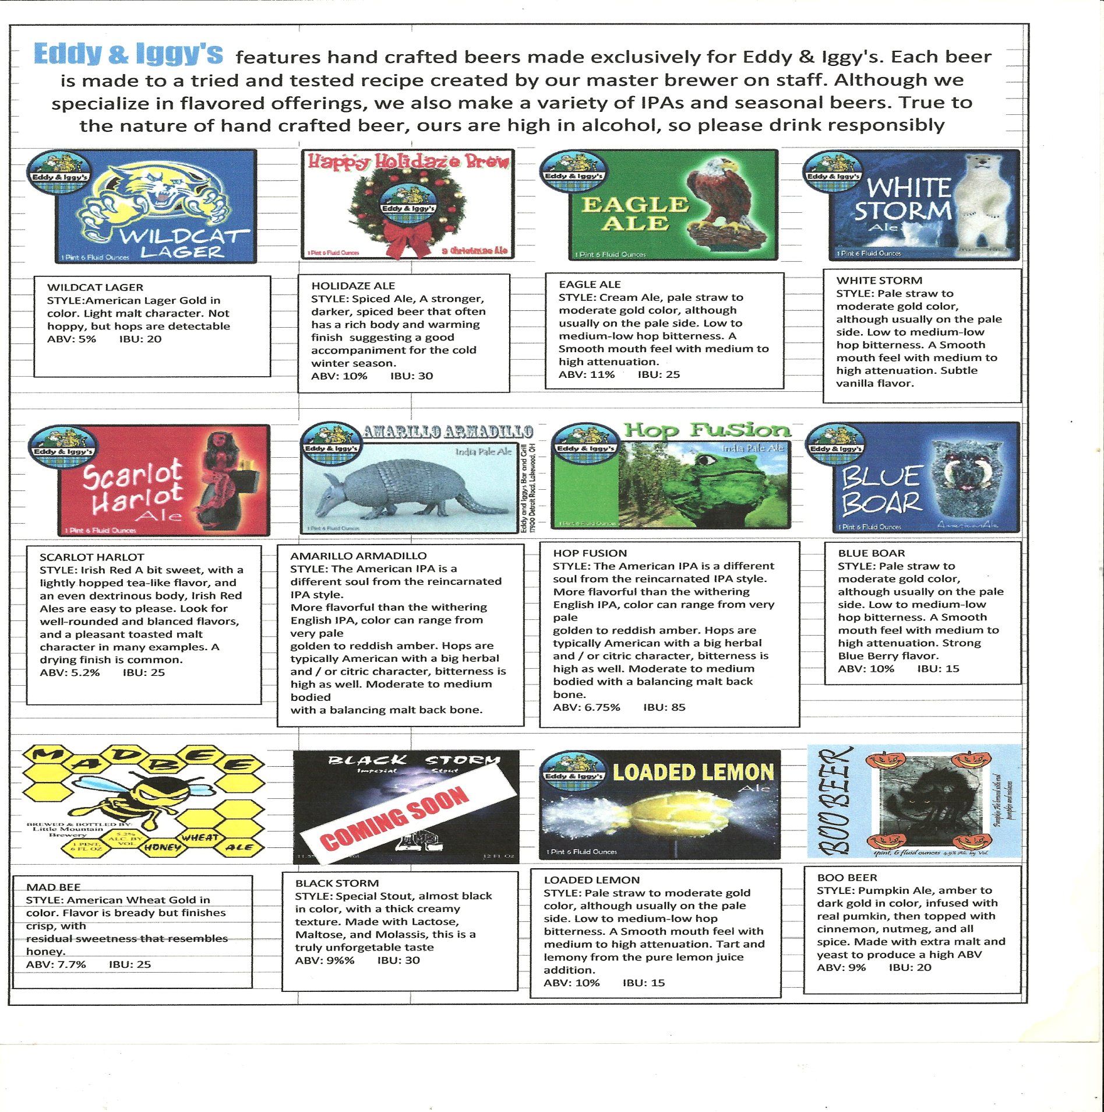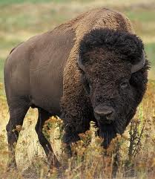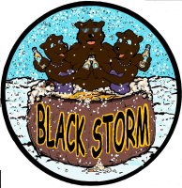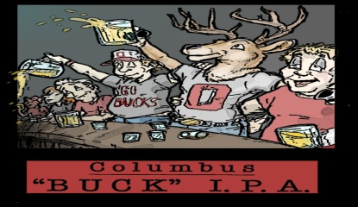

VANILLA PORTER

This medium dark porter has a rich coffee tone, with a subtle vanilla overtone

ABV: 7% IBU: 30

Vanilla Porter

Raspberry Porter

BOSCO BUFFALO

This heavy stout has plenty of chocolate flavor. A secret ingredient provides the taste, and at 10% qualifies as an Imperial.

ABV: 10% IBU: 25

Black

Storm

RASPBERRY PORTER

This medium dark porter has a rich coffee tone but combines nicely with the sweetness of the raspberry puree flavor.

ABV: 7% IBU: 30

BUCK IPA

STYLE: Imperial India Pale Ale

Very hoppy and high in alcohol. Made with Columbus Hops

ABV: 9% IBU 95